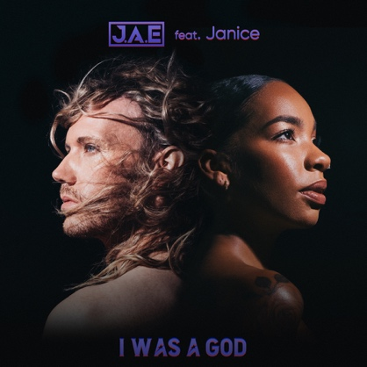

Artist: **J.A.E feat Janice**

Title: **I was a God**

Written by Erik Höiby, John Hårleman, Ella Rammelt, Elias Jonatan Kapari, Stefan Storm

Published by Flick Agency, Kobalt Music Publishing, Copyright Control, Universal Music

Label: POW! IN THE FACE! A division of Bark At Your Owner

UPC:

Catalognr: PITF064  
ISRC: SE6562300080

**J.A.E. aka Erik Höiby states:**

” Musically its very in my element of feeling like you get on a ride of storytelling. It’s a theatrical feeling in the music. Like a movie track and u can listen to its story, with its strong pulse and heaviness. The lyrics and melodies are typical J.A.E., with a light voice going against the heavy sound. And melancholic melodies make it even more dramatic and pulls u in to the story of heartache and love”

**I WAS A GOD**text: Erik Höiby; Ella Rammelt, Stefan Storm, Elias Jonatan Kapari Produktion: John Hårleman

I was a god I was a God with u And you were in love  
U were in love with me

spend all day fighting spend all hours until dawn

were looking for love  
In all of the places its wrong

didn't have my kind of patience sick of all my expectations  
no more destinations  
for you and me

tired of your hesitation  
all our twisted conversations finally found my motivation to move on

I was God  
I was a God with you  
keep falling behind  
you ran out of time with me

didn't have my kind of patience sick of all my expectations  
no more destinations  
For you and me

tired of your hesitation  
all our twister conversations finally found my motivation To move on on on

**Drivers**

J.A.E has participated in Melodifestivalen, musical theatre productions & is now collaborating with artists like Luca Debonaire, MVRE & Gatby, labels such as TGR & The Hubsters & producers that have worked with Britney Spears & Katy Perry. The new single is released by Flick Records (co-owned by Despotz Records) with PR by Bergström Public Relations. Confirmed interview by 360 Magazine. Previous singles supported by “Music & Fashion Blog”, “Alfitude”, Spotify (New Music Friday) etc.

J.A.E is known in a handful of contexts, mostly as a singer, dancer and songwriter. The smooth and powerful voice is the core to J.A.E´s joyful music, combining this with his artistic surface creates the perfect combination. On his latest single “I was a God” he joins vocal forces with million streaming RnB Pop Artsit Janice for a track that is massive in its lyrical story as well as with this powerful vocal duet.

**Playlist highlights:** New Music Friday Norway, Ny Pop. Independent Spotify playlists: "Gaming Playlist" (120k), Liquid Drum and Bass (23k) and Digster Sweden's "Digster Fresh" & "Dance Hits"

**Biography**

With years of experience as an artist, dancer, songwriter and much more ***J.A.E´s*** released his debut album as a solo artist in 2021. J.A.E´s smooth and powerful voice is the core for his music, combining this with his artistic image creates the perfect combination.

In 2019 he got the chance to participate in the Swedish music competition Melodifestivalen with his synth-duo “The Lovers of Valdaro” which became a great success. In 2020 he released the first song under the “Just. As. Erik” name, which was the official pride anthem for Kalmar, Sweden and in 2021 he landed in spotify editorial playlists such as “New Music Friday Norway” and “Ny Pop”

He is now collaborating with producers that have previously worked with Madonna, Britney Spears and Katy Perry. On his releases in 2021 he has collaborated with big artists such as Luca Debonaire and MVRE, which both have songs with millions of streams on Spotify and also with up’n’coming artists/producers such as Jovian ID, Miss Sister, Castor Cinema, Almad and Gatby (recently signed to TGR Music Group/Sony Music).

He released his debut album “PLAY” in 2021 and “Paus” album of covers in 2021 in the same year. J.A.E will release multiple tracks during 2023 through the Stockholm-based multimedia company ***Flick Agency***, co-owned by Despotz Records (Lisa Miskovsky, Adna etc). J.A.E. is now signed to POW! IN THE FACE! A division of Bark At Your Owner.

**Discover J.A.E:**

[Spotify](https://open.spotify.com/artist/6Ly2uwod1jDkU2I8otUnWa?si=U-wj5fsDQWWyBNCJt91X3w)

[Facebook](https://www.facebook.com/Just.as.erik)

[Instagram](https://www.instagram.com/j.a.e_official/)

Contact:

[Contact@barkatyourowner.se](mailto:Contact@barkatyourowner.se)

Tel: +46703755090

<https://www.barkatyourowner.se/pow-inyourface>

